Task 4 report

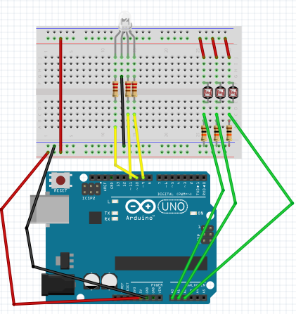

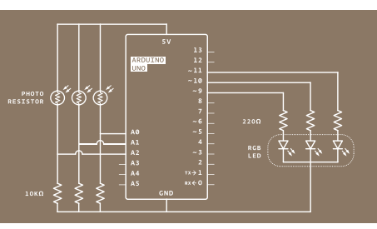

In task 4, we can through touch photoregistor to change voltage then change colour of RGB led

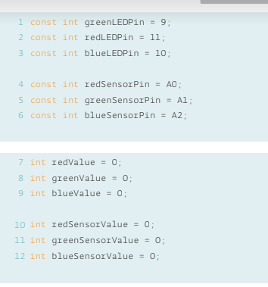

Initialization variable.

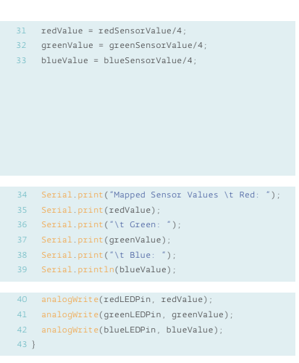

Through touch photoregister to decide which value of led pin you have to change.